Software Development Course

Software Development Level 3 Unit 1 Programming Implementation
Assessment 1

Evidence Collection

Document overview
This document records the code, execution and test evidence for Assessment 1. The Python # comments annotate the code itself, and the tables beneath each screenshot explain what the visible lines or output demonstrate.
Course information | Details
Course | Software Development Level 3
Document type | College evidence collection
Learner | Rob Johnston
Unit | Unit 1 Programming Implementation
Assessment | Assessment 1
Assessor | Alex Richards
Submission date | 29/09/2026

Evidence location
Evidence area | Verified location
Course folder | E:\OG-SCUF641_FullDataTransfer_2026-07-15_FINAL\DATA\C\OGBuild\College\Software Development L3\Software-Development-L3\Unit 1 Programming\Assessment 1
Source code | assessment_1_examples.py in the course folder above
Supporting files | test_assessment_1_examples.py and screenshots 01 to 03 in the same folder
Video evidence | Not required for this assessment

Assessment criteria covered
Criterion | What the criterion requires
PI 1.1 | Explain procedural, object-oriented and event-driven programming using statements, procedures, classes, objects, handlers and triggers.
PI 2.1 | Explain variables and identify the string, integer and Boolean data types in the supplied example.
PI 2.2 | Provide code that demonstrates sequence, selection and iteration.
PI 2.3 | Describe arrays and stacks.
PI 2.4 | Describe algorithms, including sorting and searching.
PI 2.5 | Describe testing and debugging, including breakpoints, step into and step out.

Evidence record
Reference and criterion | Evidence | My explanation of what it proves
E01 / PI 2.1-2.2 | Figure 1: Visual Studio Code lines 1 to 30 | Shows the typed variables plus # annotated sequence, selection and iteration code.
E02 / PI 2.2 | Figure 2: Visual Studio Code lines 19 to 45 | Shows the complete selection, iteration and main procedure in the IDE.
E03 / PI 2.1-2.2 | Figure 3: program execution and unit-test result | Shows the program output and confirms that all four automated tests passed.
E04 / PI 2.1-2.2 | assessment_1_examples.py | The submitted source file used in Figures 1 to 3.
E05 / PI 2.5 | test_assessment_1_examples.py | The submitted unit tests for variables, sequence, selection and iteration.
E06 / PI 1.1-2.5 | Unit 1 Assessment 1 Answer Sheet.docx | Contains the assessment explanations and the two integrated examples in each response.

Evidence item E01 Variables sequence selection and iteration
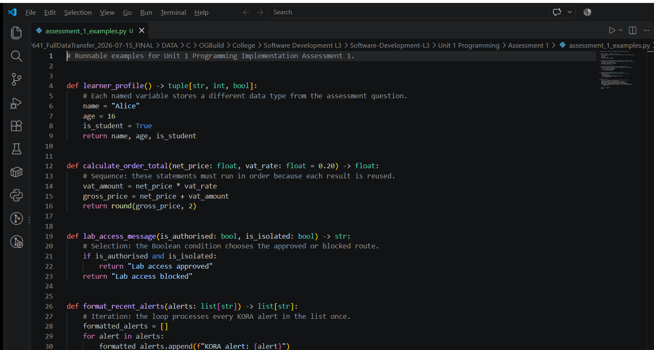
Figure 1. Assessment code open in Visual Studio Code with # comments beside each programming construct.
Code or output | Annotation
Lines 4 to 9 | The function stores Alice as a string, 16 as an integer and True as a Boolean, then returns the three named variables.
Lines 12 to 16 | The # sequence annotation identifies the dependent order: calculate VAT, add it to the net price, then return the result.
Lines 19 to 23 | The # selection annotation sits directly above the Boolean condition that chooses the approved or blocked return value.
Lines 26 to 30 | The # iteration annotation introduces the for loop that processes each KORA alert in the list.

Evidence item E02 Iteration and program control
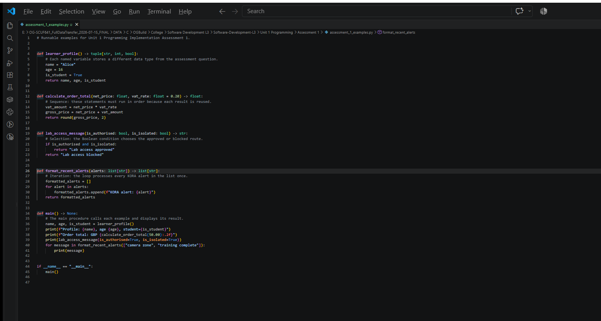
Figure 2. Selection, iteration and the main procedure shown in the same clean IDE window.
Code or output | Annotation
Lines 19 to 23 | The if condition requires both authorisation and isolation; the alternative route blocks access.
Lines 26 to 31 | The loop appends one formatted message for every alert and returns the completed list.
Lines 34 to 45 | The main procedure calls the examples, prints their results and uses the standard Python entry-point check.

Evidence item E03 Program execution and test result
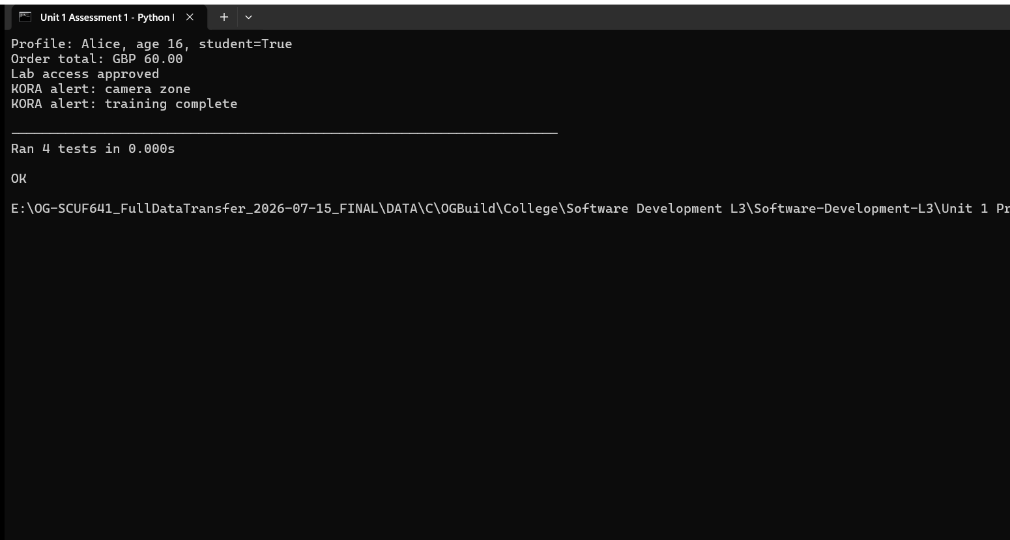
Figure 3. The submitted program running, followed by the automated unit-test result.
Code or output | Annotation
Program output | The visible values confirm the three variable types in use, the ordered VAT calculation, the approved selection route and both iterated KORA alerts.
Test summary | Python reports Ran 4 tests and OK, confirming that every defined automated check passed.
Window title | The dedicated Unit 1 Assessment 1 terminal contains no unrelated tabs or browser content.

Evidence integrity statement
Figures 1 and 2 were captured from assessment_1_examples.py in the submitted repository folder. Figure 3 was produced by running that file and its four unit tests on 29/09/2026. The screenshots have not been altered to invent code or results.

